In 2021, Roots of Peace officially initiated operations in Guatemala, focusing on the Western Highlands—a region historically characterized by inequality and poverty; limited opportunities have led to significant migration to the United States. Commencing with an in-depth study of the local population and economic dynamics, our initial efforts involved thorough research and analysis. This aimed at understanding the challenges faced by the vulnerable communities and assessing the region's value chains to identify viable economic prospects that could enhance farmers' income and overall living standards. Consequently, in November 2021, we launched the Demonstration Plots Program.
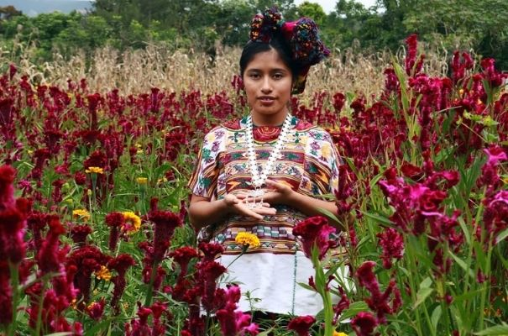
Roots of Peace is now assisting 12 farming families in the Sacapúlas Community of Quiche through its Demonstration Plots Program. Situated in one of the most important K'iche' towns, Sacapúlas is renowned for its mines of black salt production, and the creation of beautiful handmade cotton fabrics. Despite its historical significance, this community bears the scars of a prolonged internal armed conflict that spanned over 36 years, leading to profound social and economic repercussions.
In Guatemala, Roots of Peace is helping farmers in the western highlands – an area that represents one of the largest sources of migration to the US – transition from subsistence corn and bean production to high-value vegetable crops with drip irrigation, enabling them to double or triple their annual output.
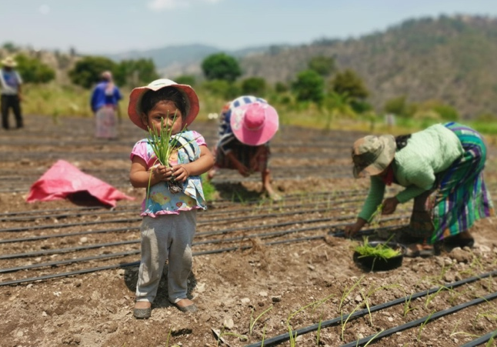
Guided by its SMART-Dev approach (Sustainable Markets and Agriculture for Resilient Transformation in Development), Roots of Peace increases smallholder farmer income by establishing intensive, competitive, and sustainable vegetable production units with efficient irrigation systems and the introduction of high-value crops. This solution strengthens production management capacities while elevating farmer incomes to ensure inclusive economic growth and increased resilience in agriculture and climate change.
By aligning agricultural practices with market demands, these family farmers have witnessed a substantial increase in their incomes thanks to the production of 20,000+ kilograms in 7,145 square meters of cultivated land so far with high-value crops, this land was previously only used for subsistence crops such as corn and beans.
Thanks to this intervention, we have been able to benefit at least 100 direct and indirect farmer clients in this community. We want to continue supporting these families to improve their living standards and help them have a dignified life in Guatemala.

To continue developing this life-changing project, we need economic support to establish the next phase of the program in 2024.

We can do even more together. Will you join us with a donation?

- A donation of $700 would cover an average intensive, competitive, and sustainable vegetable production unit.
- A donation of $300 would cover an efficient irrigation system for one of our farmers.
- A donation of $250 would cover seedlings for a small farmer’s vegetable production.

The project will leverage the presence and expertise of local organizations with Roots of Peace providing the necessary inputs, technical assistance, and market connections to help provide living wages for these farming families and provide them with a strong alternative to immigration.

Join us, as we begin to plant the Roots of Peace in Central America.

